

**SECP1013-09 TECHNOLOGY AND INFORMATION SYSTEM**

**Design Thinking Project Report**

**Product Name: Deepfake Detection Application**

**Group Members:**

|  |
| --- |
| 1. Fong Jin Xuan A24CS0074 |
| 1. Eii Zhi Hui A24CS0246 |
| 1. Qian Wen Jun A24CS4032 |
| 1. Lau Zhi Ying A24CS5020 |
| 1. Lee Jian Yi A24CS5075 |

Prepare for: Dr. Pang Yee Yong

**TABLE OF CONTENTS**

|  |  |  |
| --- | --- | --- |
| No. | Content | Page number |
|  | Introduction | 3 |
|  | Detailed Steps | 4 |
|  | Detailed Description | 6 |
|  | Design Thinking Assessment Points | 9 |
|  | Design Thinking Evidence | 10 |
|  | Reflection | 13 |
|  | Task Distribution | 16 |
|  | Reference | 17 |

**INTRODUCTION**

Design thinking is an approach to problem-solving and innovation that is used in various fields. It is user-centric and more solution-based. This means that it focuses on humans first instead of the problem itself and helps to understand user’s needs then come up with effective solutions.

Design thinking often involves five phases, namely Empathize, Define, Ideate, Prototype and Test (as shown in Table 1).

|  |  |
| --- | --- |
| **Phase 1:**  **Empathize** | This phase is aimed to develop a deep understanding of the target audience’s needs and objectives. This involves research methods, such as user research, surveys and interviews. During the phase, a team will have a real insight into their target user. |
| **Phase 2:**  **Define** | After gathering information collected from the previous step, a core problem is defined. The problem should be ideally stated from a human-centered perspective instead of business goals. This phase acts as the foundation of the design process. |
| **Phase 3:**  **Ideate** | With the foundation ready, teams start working on potential solutions in this phase. The teams start having brainstorm sessions to collect as many ideas as possible. The ideation stage enables exploration of solutions and creative ideas. All ideas generated are further discussed and clarified after brainstorming. |
| **Phase 4:**  **Prototype** | This phase is where experiments happen. A prototype is a scaled-down versions and inexpensive product to test and investigate the ideas. Prototype can be made in various medium, and the simplest ones may be paper prototypes. This step is aimed to get feedback from targeted audiences for modification or redesign process. |
| **Phase 5:**  **Test** | This is the final stage of design thinking process, where the prototypes are tested by real users to gather actionable feedback and reactions of users. Then, reflections on prototype’s performance are made and previous phases may be repeated to create the best solution. |

Table 1: Five Phases of Design Thinking

**DETAILED STEPS**

The given theme for this project is big data and artificial intelligent new innovation. After getting this theme, what first came into our mind was deepfake fraud cases which are happening frequently. We decided to come out with a system that could detect deepfakes generated by artificial intelligence (AI). Digital devices users could get involved in deepfake fraud cases, whom will be our targeted users.

**2.1 Empathize**

In this technologically advanced era, people are closely connected with technological products. Most of the people own digital devices, becoming the potential victim of AI fraud and deepfake content. Deepfake nowadays includes face swap, voice cloning, AI-generated text, social media manipulation, and many more. It is difficult for users to detect or recognise deepfakes. To have a better understanding, we surveyed our targeted users through Google Forms to know the problems users faced and their worries. To immerse ourselves in what users experienced, we used remaker.ai and tried to swap faces for photos (as shown in Figure 1). We were shocked by how realistic the photos can be and understand the users’ concern.



Figure 1: Original Photo, Target Face and Product Photo of Face Swap

(Source: https://remaker.ai/face-swap-free/)

**2.2 Define**

After the empathize phase, we understood the concerns and needs of users. We concluded 3 problems that most of the users faced, as shown in Table 2. As all of us know, deepfake is difficult to detect and there is not much time for us to find out whether the content is deepfake or not when it is happening. It would be very helpful for users and could reduce the chance of them being deceived if there is a system that could detect deepfake.

|  |  |
| --- | --- |
| No. | Problems faced by users |
| 1. | Deepfake content is difficult to detect |
| 2. | Verifying deepfake content takes a lot of time and effort |
| 3. | Lack of resources to identify deepfake content |

Table 2: Problem Faced by Users related to Deepfake

**2.3 Ideate**

We discussed and brainstormed together to develop as many ideas as possible. Some ideas include developing detection algorithms, implementing forensic tools, developing authentication solutions. From all the ideas generated, we agreed that the solution for all three problems stated is to develop a system that detects deepfakes.

**2.4 Prototype**

After coming out with the idea, we started discussing the details of our prototype including the design of the prototype and elements to be included in the prototype. We decided to develop our prototype using Figma. At the stage of building the prototype, we kept reminding ourselves of what we were hoping to solve to make sure we were focussing on the topic.

**2.5 Test**

After the prototype was finished, we found some users to test our prototype. While testing the prototype, we observed the whole process and listened to the feedback of the users. This is a chance for us to know where and what to improve for our product.

**DETAILED DESCRIPTION**

**3.1 Problem**

In today’s digital era, the rapid development in science and technology has made it possible to generate false information and content online without effort. This creates a significant effect and risk not just for individuals, but also to organisations and society. Deepfake contents have become increasingly complex and realistic, making them difficult for users to identify and differentiate from the real content. The situation is worsened by the fact that Malaysia has Internet and smartphone penetration rate of more than 90 percent.

As artificial intelligence (AI) technology improves, the problem of deepfake is getting worse. Many users believe that deepfakes are of great concern and detecting such content is becoming increasingly difficult. The process to verify the content is time-consuming and labour-intensive, which is further worsened by the lack of resources to identify those deepfake contents, making users become frustrated and vulnerable to deception. Recognising these challenges provides opportunities for innovation across many industries. Having an application that can detect deepfake content in real-time is very beneficial for content verification. These findings highlight the urgent need for a reliable, efficient and user-friendly solution for users to address the growing threat arise by deepfake techniques in the digital world.

**3.2 Solution**

After discussions and recognising the problem through brainstorming, we have found a way that we can solve these problems. To address the issue of detecting deepfake content, our team developed an application, named Deepfake Detection Application. This application can use an advanced checking system to help users to identify and verify the authenticity of the content in real-time.

Our application is designed with some key features that directly address the user's needs. It offers real-time detection, which allows users to upload videos and photos from their gallery or camera for analysis within seconds. The application also has a user-friendly interface to make sure it is simple to use and accessible to all users. It is very easy to use and requires only a mobile phone to use.

Although AI can make fake content completely different from the original content, there are still some fixed characteristic points and patterns in the text or image generated by the AI model that can be captured by the checking system. By prioritizing accuracy, speed and ease of use, the Deepfake Detection Application enable users to verify digital content confidently. It also effectively addressing the effect caused by deepfake technology.

**3.3 Team Working**

To make sure that the project goes according to the plan, we first discussed our product topic. After listing different types of product names, we chose Deepfake Detection Application, which stood out among other topics after discussion and research. We put a lot of effort into the development of the application with each team member contribute their skills and knowledge.

Tasks were assigned to each member to maximize efficiency and individual strengths. Qian Wen Jun created a Google survey form to gather respondent feedback to form the application design and write the contents of design thinking assessment points. Fong Jin Xuan led the design of the application prototype to ensure a good user experience and contributed to the report by writing the introduction section. Eii Zhi Hui focused on testing the prototype to ensure the application is functioning at the same time providing evidence of design thinking in the report. Lau Zhi Ying recorded the detailed steps of the development process and produced a video to present the product’s features. Lee Jian Yi was responsible for writing detailed descriptions in the report and preparing presentation slides.

We began the project by collecting data on user problems and requirements related to deepfake detection from the respondents. The insight obtained from the survey solved the design and development of the application to ensure address user issue. We shared all opinions and ideas on WhatsApp and put them into the report using Microsoft Word. Through our teamwork, we successfully developed a functional prototype of the Deepfake Detection Application.

**DESIGN THINKING ASSESSMENT POINTS**

During the empathize stage, our group discussed the product we can make based on the theme given to us, which is big data and artificial intelligent new innovation. We connect our thoughts to deepfake fraud that is frequently mentioned on various platforms. Based on this idea, we started our survey to study opinions of digital users towards deepfake and did research about deepfake technology, which included trial of a face-swap website.

In define phase, we collected the data from surveys conducted. Respondents’ opinion and key problems faced are analysed in the same phase by listing down the problems.

Moving to ideate phase, we brainstormed solutions for the problems listed in define phase. Every idea and solutions suggested by group members are recorded. After that, we filtered the suggestions and chose an optimal solution to the problems.

Next, in the prototype phase, we create a prototype using the solution chosen from ideate phase, which is Deepfake Detection Application. This allows users to either detect deepfake in a real-time behaviour or upload media from gallery to identify deepfake content. This product promotes a simple and accessible interface to ease the deepfake detection process of users.

Lastly, we came to testing phase. We gathered users to test the prototype made. We observed the testing process and listened to the feedback of users for further modification.

**DESIGN THINKING EVIDENCE**

**Empathy phase**

We conducted a survey using Google Form to access users’ opinions regarding deepfake technology.

Figure 2: Question list in Google form

**Define phase**

In this stage, we collect information by employing survey forms to identify users’ opinion on deepfake technology. By analyzing the data, we identified the problems faced by users.

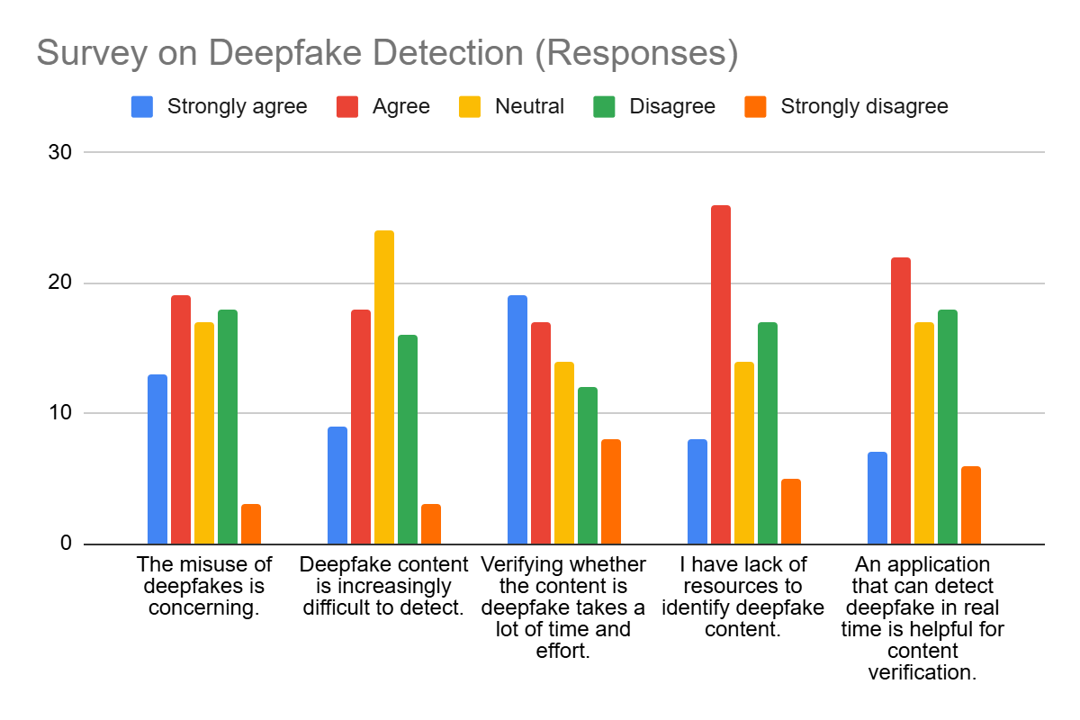

Figure 3: Data Gathered from Survey Form

**Ideate phase**

We held several discussions to list potential solutions to the problems. After brainstorming sessions, we selected the best solutions to finalized and generated the idea to develop deepfake detection application.

Figure 4: Evidence of Discussion Process

**Prototype phase**

We used the data collected from survey forms to design a prototype which can solve the problems faced by users related to deepfake technology. The prototype design is as shown in Figure 5.

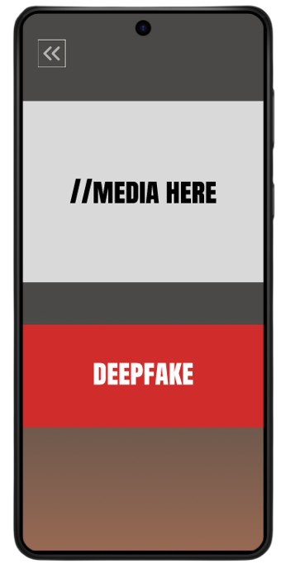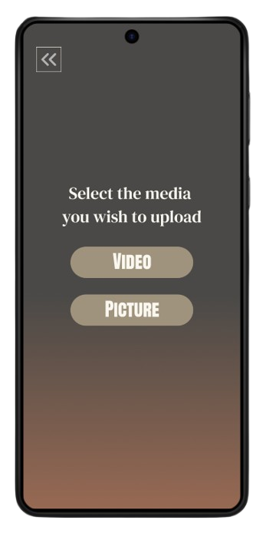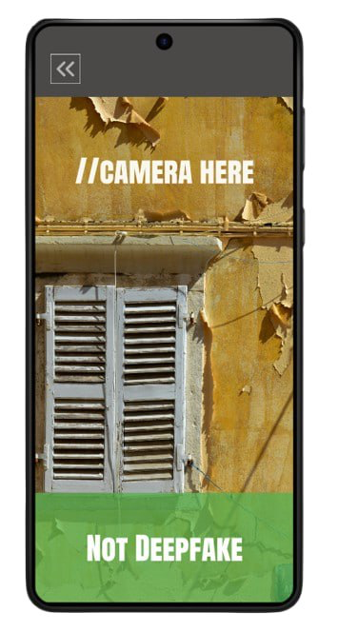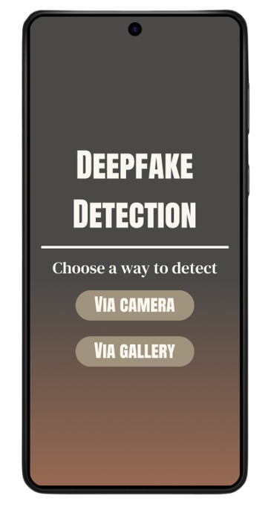Figure 5: Application Prototype

**Testing phase**

In this phase, we gathered feedback from the users by observing them interacting with our prototype. This valuable feedback enables us to refine the solution and improve its functionality.

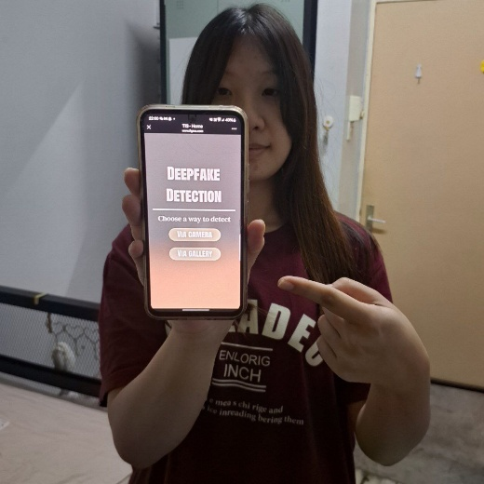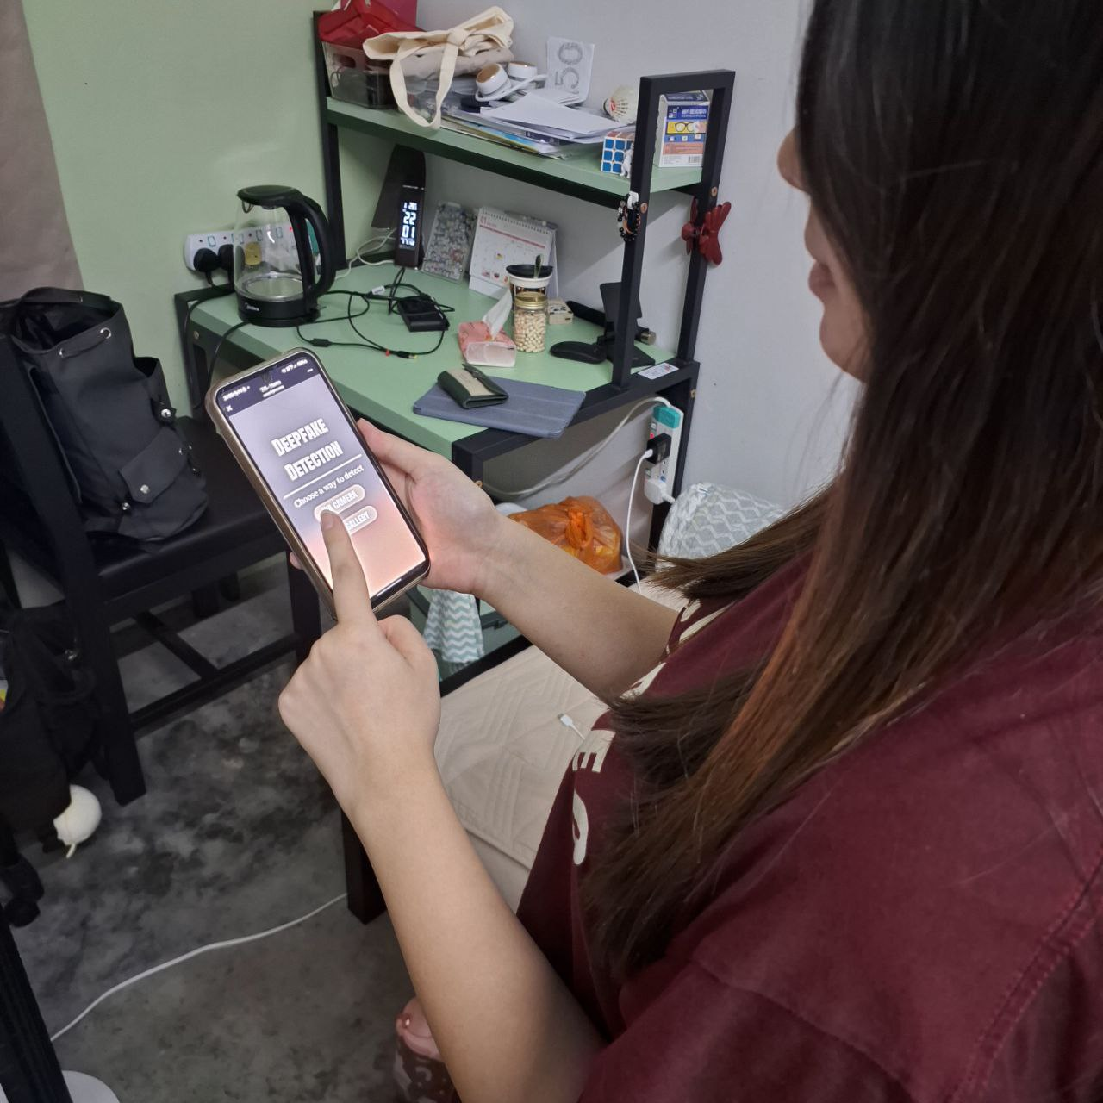

Figure 6: Evidence of user testing prototype

**REFLECTION**

**1. Fong Jin Xuan (A24CS0074)**

**a. What is your goal/dream with regard to your course/program?**

My goal regarding my course is to learn about fundamentals of computer science from both theoretical and practical aspects. I aim to use these skills learned in my future career and contribute to technology industry.

**b. How does this design thinking impact on your goal/dream with regard to your program?**

This improves my project management skills. I get to collaborate with groupmates to design a product that meets needs of audiences which improves my teamworking skill. Throughout the project, I also have an exploration on fields and some basic concepts of computer science that enable me to know exactly what I am interested in computer science world.

**c. What is the action/improvement/plan necessary for you to improve your potential in the industry?**

To improve my potential in the industry, it is important for me to have a plan on what to learn in four years of the program. Also, I plan to involve myself in projects and extracurricular workshops to improve my skills that are essential in technology industry. I will also develop my soft skills to ease the process in further projects.

**2.Eii Zhi Hui (A24CS0246)**

**a. What is your goal/dream with regard to your course/program?**

My goal with regard to my course is to enhance programming techniques and coding experience. This will enable me to develop mini games or join a game studio to create mobile games in future.

**b. How does this design thinking impact on your goal/dream with regard to your program?**

I have learned that team collaboration and communication are key of this project to addressing challenging problems as well as gathering different and creative ideas from teammates. Additionally, this project enhance my problem solving skills by introducing me design thinking process which are empathy, define ,ideate, prototyping and deploy.

**c. What is the action/improvement/plan necessary for you to improve your potential in the industry?**

As a first year student, I will continuously learning fundamental knowledge of computer science to improve my potential in the industry. Additionally, I will actively participate in coding competitions such as hackathons to enhance my coding experience and expand my social circles.

**3. Qian Wen Jun (A24CS4032)**

**a. What is your goal/dream with regard to your course/program?**

I hope that the idea of our group - the function of detecting AI - related fraud can be realized as soon as possible, so as to reduce the probability of the public being deceived.

**b. How does this design thinking impact on your goal/dream with regard to your program?**

Through this learning experience, I have come to realize the importance of teamwork. When everyone's ideas clash, wonderful sparks are generated.

**c. What is the action/improvement/plan necessary for you to improve your potential in the industry?**

In future studies, I will pay more attention to industry trends and study hard.

**4. Lau Zhi Ying (A24CS5020)**

**a. What is your goal/dream with regard to your course/program?**

My goal regarding my course which is graphic and multimedia software is to develop my own product, whether an application, a system, a website, or any other product. I wish to expertise and apply what I have learned well in the future. It would be a great sense of accomplishment for me to design a product that could benefit the public.

**b. How does this design thinking impact on your goal/dream with regard to your program?**

This design thinking has increased my knowledge regarding designing and developing a product. It is important to learn design thinking and follow the process while designing something as it could enable the whole process to be done smoothly. Through this project, I also gained experience in designing products with others and learned to work as a team.

**c. What is the action/improvement/plan necessary for you to improve your potential in the industry?**

To improve my potential in the industry, I should strive to improve my professional abilities. What I could do now is put my effort in my academic so that I could master and apply what I have learned. Other than that, I will try to practice more and improve my practical experience as practice make perfect.

**5. Lee Jian Yi (A24CS5075)**

**a. What is your goal/dream with regard to your course/program?**

My goal regarding my course is to learn more about computers and improve my thinking ability. I also need to recognize problems and then solve them. I want to learn more new skills and techniques to gain more experience so that I can contribute my ideas and thoughts to the world.

**b. How does this design thinking impact on your goal/dream with regard to your program?**

This design thinking project gave me the opportunity to collaborate with other people. It taught me the power of unity and enhanced my teamwork skills. Besides that, I also learned how to express my opinions and ideas to other team members to find the best solution, which will be useful in the future.

**c. What is the action/improvement/plan necessary for you to improve your potential in the industry?**

To improve myself, I need to stay update with industry design trends and technology updates. I also planning to gain knowledge about programming languages as much as possible and learn new techniques through courses and tutorials. In addition, I seek inspiration from various source such as art, culture and nature.

**TASK DISTRIBUTION**

|  |  |  |
| --- | --- | --- |
| No. | Name | Tasks |
| 1. | Fong Jin Xuan  A24CS0074 | * Report writing (Introduction) * Design prototype |
| 2. | Eii Zhi Hui  A24CS0246 | * Report writing (Design thinking evidence) * Test prototype |
| 3. | Qian Wen Jun  A24CS4032 | * Report writing (Design thinking assessment points) * Prepare survey form |
| 4. | Lau Zhi Ying  A24CS5020 | * Report writing (Detailed steps) * Video preparation |
| 5. | Lee Jian Yi  A24CS5075 | * Report writing (Detailed descriptions) * Presentation slides preparation |

**REFERENCES**

GeeksforGeeks. (2024b, May 27). *5 stages in the design thinking process*. GeeksforGeeks. https://www.geeksforgeeks.org/five-phase-model-for-design/

Control, V. (2023, October 9). *5 steps of the Design Thinking Process: A Step-by-Step Guide*. Voltage Control. https://voltagecontrol.com/blog/5-steps-of-the-design-thinking-process-a-step-by-step-guide/

*Face Swap online free*. (n.d.). https://remaker.ai/face-swap-free/